COMP231-S62G1

Group 1

Food order app – User guide for Customers

Table of Contents

Purpose 2

Browsing the Application 3

Browsing Restaurants and Menu Items 3

Going Back to the Restaurant List 4

Using the Shopping Cart 5

Adding an Item to the Cart 5

Viewing the Shopping Cart 6

Managing the Shopping Cart 7

Placing an Order 9

Going to the Order Confirmation Page 9

Receiving Updates 11

# Purpose

The main purpose of this application is to allow users to order food items from multiple restaurant vendors from their android device. The user does not have to wait in-line, and is notified when their order is ready for pick-up.

The core functionality of the application is as follows:

1. Identification: Logging in to the application
2. Browsing the application: browsing restaurants and its menus
3. Using the shopping cart: adding and managing items in the shopping cart
4. Placing an order: order confirmation and sending an order to the vendors
5. Receiving Updates: status updates and confirmation that the order is/has been processed

# Browsing the Application

Each user will have the ability to select the restaurant(s) of choice and select items to order from any restaurant. On each menu item, there is an option to select the details of the item and the quantity the user would like to purchase. The user also has the ability to select items from multiple restaurants in one session.

## Browsing Restaurants and Menu Items

This section outlines how to browse through the lists of items available. On the first page, each restaurant is listed. When a restaurant is clicked, a list of offered menu items are displayed.

1. Start the application.
2. Browse through the list of restaurants. If necessary, slide your finger vertically up or down on your android device to scroll through the list.

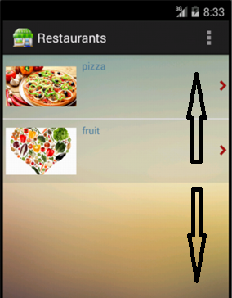

1. Select a restaurant by touching/selecting the item on the touchscreen of your device.

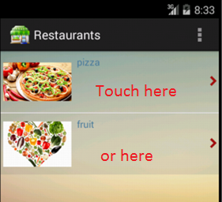

1. Browse through the list of menu items. If necessary, slide your finger vertically up or down on your device to scroll through the list.

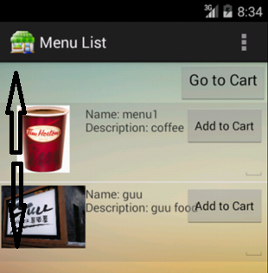

* You have successfully navigated to a list of menu items for a restaurant.

## Going Back to the Restaurant List

This section outlines how to navigate back to the list of restaurants.

1. Click the “back” arrow on your device. This takes you back to the list of restaurants.

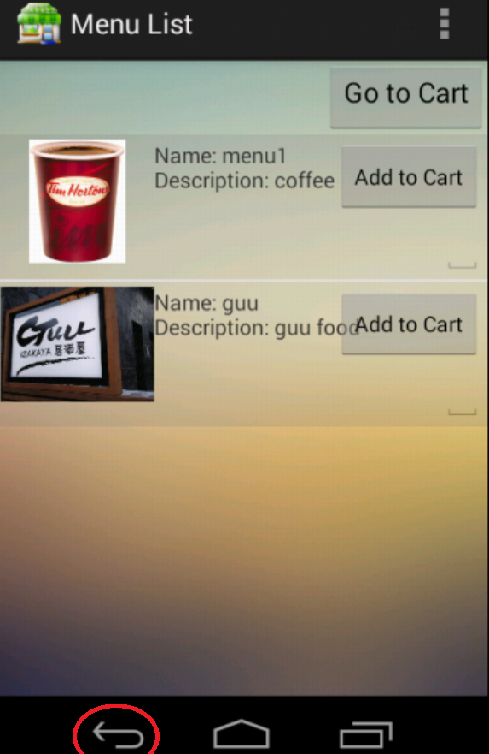

* You have successfully navigated back to the restaurant list.

# Using the Shopping Cart

The shopping cart will manage what the user wants to purchase. In addition to selecting the quantity of the order on the menu item, the user is able to update the quantities and remove items in the shopping cart.

## Adding an Item to the Cart

This section outlines how to add a menu item to the cart.

1. Navigate to the restaurant menu of choice. See steps from “Browsing the Application” for more information.

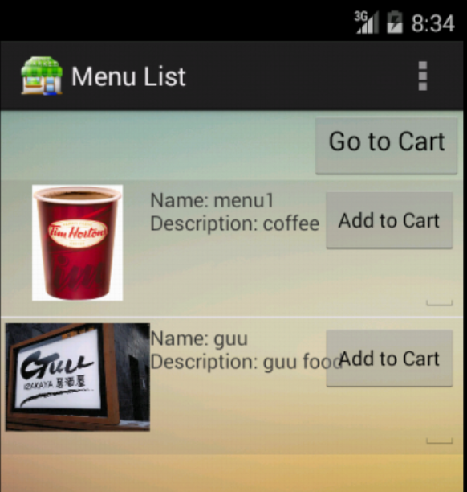

1. Enter the quantity by touching the text field on the device screen and typing in the number.

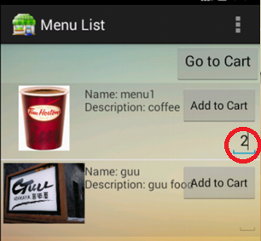

1. Select “Add to Cart” button.

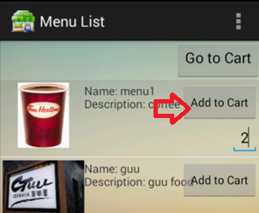

1. Repeat steps 1-3 for all other items.

* Items are successfully added to the shopping cart.

## Viewing the Shopping Cart

This section outlines how to go to the Shopping Cart page.

1. Navigate to the restaurant menu of choice. See steps from “Browsing the Application” section for more information.



1. Select “Go to Cart”.

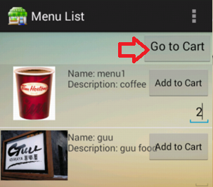

1. The items that were added to the cart are displayed on this page.

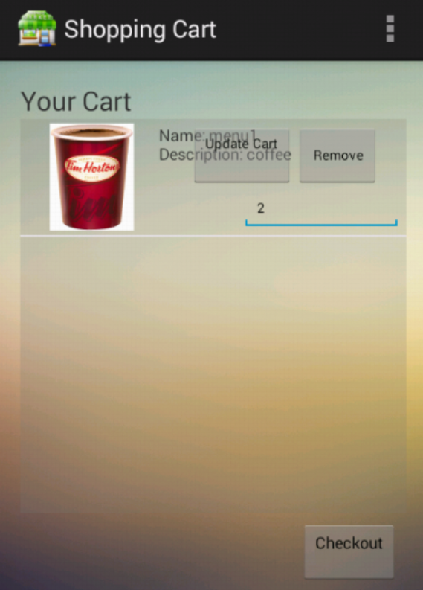

* Successfully viewed the shopping cart.

## Managing the Shopping Cart

This section outlines how to remove and update quantities for the items added to the Shopping Cart.

1. Navigate to the Shopping Cart. See steps from “Viewing the Shopping Cart” section for more information.



1. The following options are available:
   * Remove an item: Select “Remove” on the item of choice

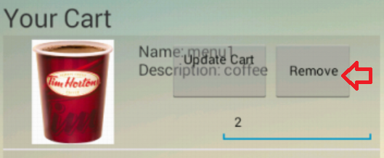

* + Update quantity: Touch the text field on the device screen where the quantity is displayed and retype in the correct number. Select the “Update” button.

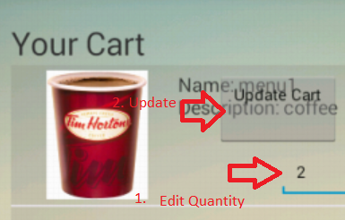

* Successfully remove an item or update the quantity of an item.

# Placing an Order

The order page will allow a user to confirm what items are being ordered. An order placed is paid for using a prepaid card that was purchased beforehand.

## Going to the Order Confirmation Page

This section outlines how to initiate the process to place an order.

1. Navigate to the Shopping Cart. See steps from “Viewing the Shopping Cart” section for more information.



1. Select “Checkout”.

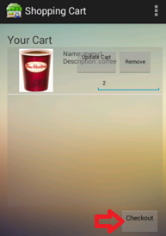

1. The Order Confirmation Page is displayed.

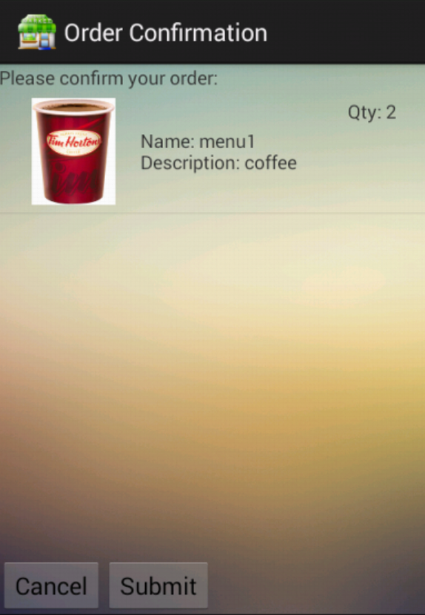

* Successfully initiate an the order placing process

TBD

# Receiving Updates

TBD